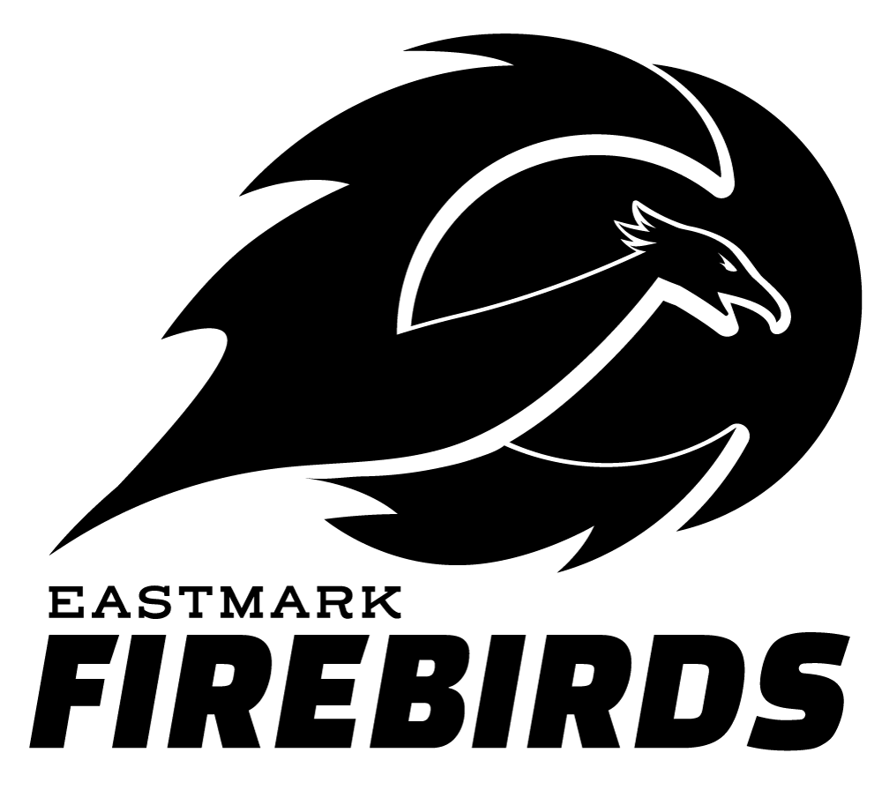
Eastmark High School Band Boosters
2026-2027 School Year

Dear Local Business Owner:

The Eastmark High School Band Boosters is a community volunteer organization dedicated to supporting the efforts of the Eastmark High School Band Program. As we prepare for the 26-2027 school year, we are focusing on developing the students musical skills and knowledge to help prepare us for an exciting year of performances on campus, around our community, and nation-wide. We are also looking forward to opportunities to work with specialists in the music field to continue to help the band students grow. As we embark on this journey of music-making and building strong character attributes in the students, we would very much appreciate your partnership and support!

The EHS Band Program consists of the seven thriving ensembles: The Firebird Marching Band, Symphonic Winds Ensemble, Percussion Ensemble, Concert Band, Cadet Band, Jazz Band, and Winter Guard. The students who participate in these ensembles are 7th to 12th graders. A major focus of the program is helping the student grow their interpersonal skills and become a positive presence in the community. They learn accountability, commitment, responsibility, teamwork, and discipline and often become leaders and positive citizens in our community. The students will invest countless hours of individual practice, ensemble rehearsals, and preparation toward this starting now and continuing through the entire 26-2027 school year. Our Booster Team is extremely proud of the recent success of the program placing in some of the top ranks in the nation and country. We presently support approximately 150 students and are the fastest growing band program in the district. We are looking forward to representing our local community, school, district, and the great state of Arizona.

Like with many activities, this activity of music-making and character building does not come without an investment. In addition to our ongoing fundraising efforts throughout the year, we are specifically reaching out to you for support in the manner of sponsorship, meal donation, and/or spirit/fundraising events. These generous donations will help to cover operational costs that are unfortunately out of the realm of our current school district and state funding.

With your generosity, you will help us reach our fundraising goal of $50,000.00 to meet our budget for the 26-2027 school year.

Your donation supports expenses for:
- Music / drill choreography arranging
- Marching band and winter guard show props
- The repair / replacement of existing instruments and equipment
- Transportation and travel costs for the students
- Uniforms
- Competition and festival entry fees
In addition to these operational expenses, it is our goal to provide meals to the students during key events throughout the school year, when they will be expected to work and perform for several hours during the day. We will be taking the band program to music festivals around the country to showcase our wonderful talents and learn from some of the greatest musicians in our country.

Your donation will make a difference!!!!

You may make a monetary donation (tax-deductible) Tax ID# 84-3964390 by choosing one of the Sponsorship Levels on the attached pages. For your donation, you will receive commensurate advertising benefits and more.

You may also donate in the manner of meal sponsorship or offer a fundraising opportunity for the program and receive commensurate advertising benefits. Please see attached pages for all opportunities available to fit your sponsorship best.

If you have any questions, please contact me, Carissa, Booster Fundraising Lead, at eastmarkbandboosters@gmail.com. Thank you in advance for your consideration and we look forward to your support!!!
Sincerely,

Carissa and Nicole
EHS Band Booster Fundraising and Hospitality Leads
eastmarkbandboosters@gmail.com

Eastmark High School Band Boosters
2026-2027 SPONSORSHIP FORM
PAGE 1

Support the entire EHS Band Program by being a sponsor!
Your donation goes directly towards improving our award winning ensembles.
All donations are 100% tax deductible.

FOLLOW THESE STEPS:

- Fill out this 2 page form.
- Make check payable to EHS - ABC
  - Other payment options are available, please contact: eastmarkbandbooster@gmail.com
- Arrange for form and payment/donation to be picked up by a booster representative. OR email completed form to eastmarkbandboosters@gmail.com and we will coordinate payment/donation options with you.
- Please be sure to include your business graphic (gif, jpg, png) so we can thank you for your sponsorship.
- - - - - - - - - - - - - - - - - - - - - - - - - - - - - - - - - - - - - - - - - - - - - - - - - - - - - - - - - - - - - - - - - - - - - - - - - - - - - - - - - - - Company Name
______________________________________________________________________________
Contact Name ______________________________________________________________________________
Address:
______________________________________________________________________________
Contact Phone:
_____________________________________________________________________________
Email:
_____________________________________________________________________________
Eastmark High School Band Boosters
2026-2027 SPONSORSHIP FORM
PAGE 2
SPONSORSHIP LEVELS  - Hero Level - $1,300 if commit by 8/15/26 or normal sponsorship rate is $1500  - Vinyl Banner to be placed in the gym or football field for the 26-27 school year, as well as all items listed in the Champion and Supporter Levels.  - Advocate Level - $600 if commit by 8/15/26 or normal sponsorship rate is $750  - Vinyl Banner to be placed on Trailer for the 26-27 school year, as well as all items listed in the Champion and Supporter Levels.  - Champion Level - $400 if commit by 8/15/26 or normal sponsorship rate is $500  - Logo on back Team Shirts for the 26-27 school year, as well as all items listed in the Supporter Level.  - Supporter Level - $150 if commit by 8/15/26 or normal sponsorship rate is $200  - Advertisement on all EHS Band and Booster social media including the Booster Webpage during the 26-27 school year, Logo on all EHS Band Programs during the 26-27 school year, and verbal/written thank you.  - Custom amount/donation___________  - Advertising will be discussed. | FOOD DONATION  - Provide 2 or more Meals for the 20+ Band Events during the 26-27 school year, or a Meal and a Fundraiser.  - Logo on back of team shirts, Advertisement on all EHS Band and Booster social media including the Booster Webpage during the 26-27 school year, Logo on all EHS Band Programs during the 26-27 school year, and verbal/written thank you.  - Provide a Meal/Food Items for one of the 20+ Band Events for the 26-27 school year-  - Advertisement on all EHS Band and Booster social media including the Booster Webpage during the 26-27 school year, Logo on all EHS Band Programs during the 26-27 school year, and verbal/written thank you.  - Fundraising/Spirit Night Event-  - Advertisement on all EHS Band/ Booster social media during the month of the event. Logo on an EHS Band Program.

